# Organizing with CTEs

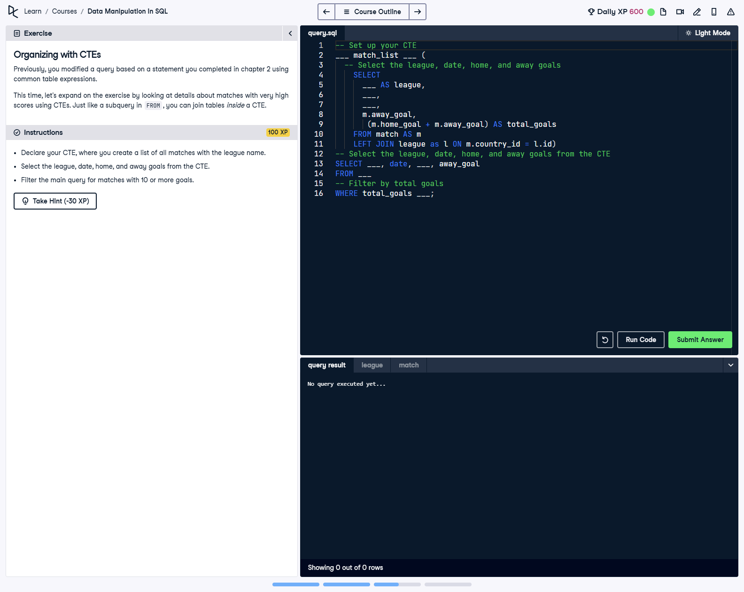

## Question

1. Declare your CTE, where you create a list of all matches with the league name.  
  
2. Select the league, date, home, and away goals from the CTE.  
  
3. Filter the main query for matches with 10 or more total goals.

## Corrected Solution

-- Set up your CTE  
WITH match_list AS (  
 -- Select the league, date, home, and away goals  
 SELECT  
 l.name AS league,  
 m.date,  
 m.home_goal,  
 m.away_goal,  
 (m.home_goal + m.away_goal) AS total_goals  
 FROM match AS m  
 LEFT JOIN league AS l  
 ON m.country_id = l.id  
)  
-- Select the league, date, home, and away goals from the CTE  
SELECT  
 league,  
 date,  
 home_goal,  
 away_goal  
FROM match_list  
-- Filter by total goals  
WHERE total_goals >= 10;

## Explanation

This query uses a Common Table Expression (CTE) named match_list to organize data logically. The CTE joins the match table with the league table to include the league name. It calculates the total goals (home + away) for each match and includes relevant match details. The main query filters the results to show only matches with 10 or more total goals, simplifying analysis.